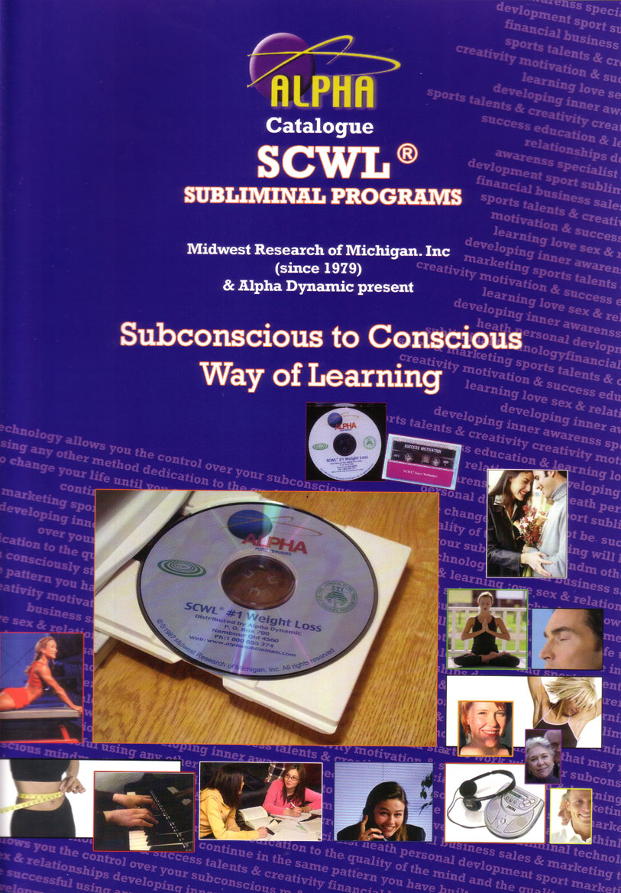
Dedicated to Improving
the Quality of Life
LETTER FROM THE PRESIDENT:

Thank you for taking the time to enquire about SCWL® Subliminal Programs. Inside this catalog, you’ll learn about a scientifically proven product that has literally helped thousands of people enjoy a better and more productive life-style while accomplishing their most important goals. SCWL® is fascinating the way it works so effortlessly to create our desired results.

If I were to ask you what the most powerful thing on this earth was, would you say it was a thought? You’d be absolutely right! Everything that surrounds you was first a thought in someone’s mind, a chair, a plane, a pen, a computer, even a cup, were all first a thought. The most powerful ability each of us possess is the power of our own thinking... the power to create from thought, anything you can conceive and believe in.
The difference between people is directly related to the quality of their thinking.

It is to the quality of thinking that Midwest Research of Michigan, Inc. is dedicated.
You can change your life by changing your thinking. This concept is what all positive thinking books are telling us. If we desire a change in our life, we must do something that changes our thinking. Thinking is the conscious minds’ activity; however, it is completely influenced by our subconscious beliefs - beliefs that have often taken a lifetime to form. If we sincerely desire a change in our life, we must change or alter what we believe about ourselves in our subconscious mind.

SCWL® subliminal programs will help you make those positive changes in your life. Join the millions of people around the world who have made dramatic changes in their lives with the help of SCWL® subliminal programs.

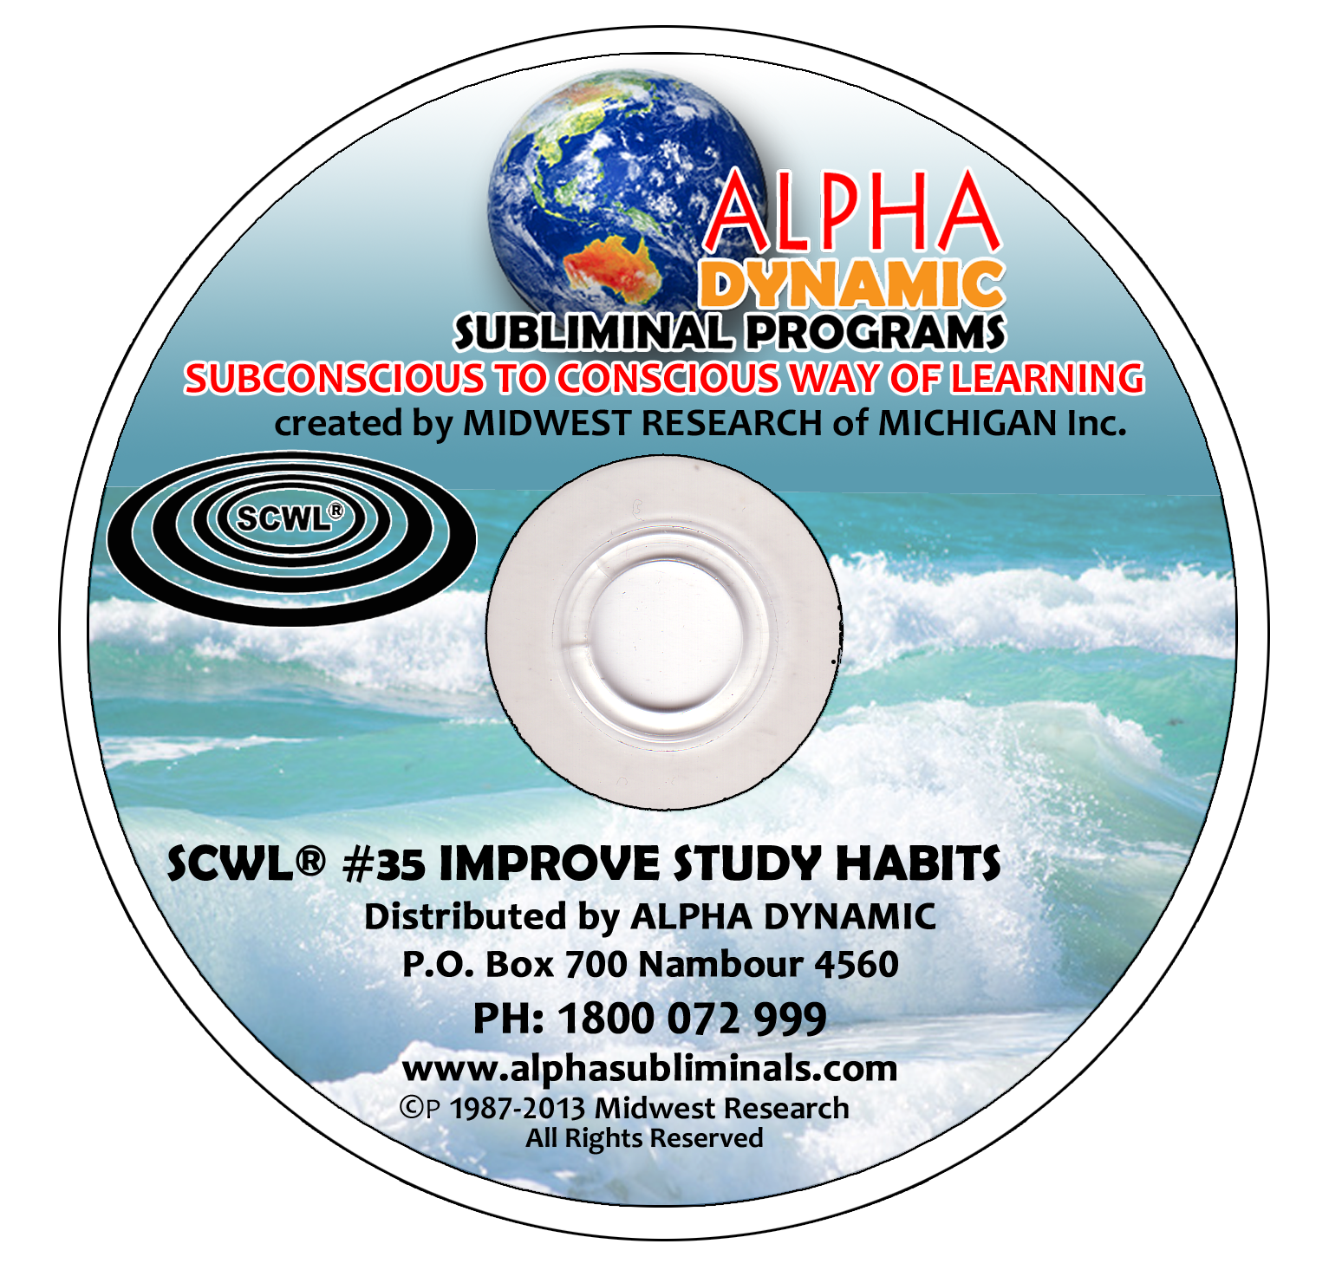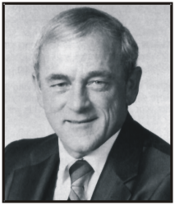
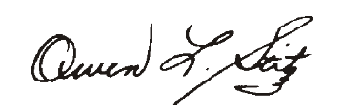
The subliminal programs contained on this site may well represent the most powerful tools for your self improvement and personal development you have ever found.
By using subliminal programs presented here you can……..
- Use more of the power of your mind to improve any aspect of your life
- Reinforce and accelerate the achievement and realisation of your chosen goals
- Change self limiting attitudes and beliefs into powerful internal motivation
- Accelerate learning ability - improve memory, concentration and problem solving, read faster and retain more
- Eliminate fear and worry, anxiety and depression. Bypass the limitations of your conscious mind where these self limiting thoughts and doubts exist

Our SCWL subliminal programs replace negative thinking with carefully scripted positive affirmations that motivate you to move forward and improve fast
- You can develop a new sense of well being on all levels developing skills and natural abilities from the inside out
- Improve your prosperity and ability to manifest money or opportunities
- Develop greater creativity, imagination and intuition
- Boost happiness and self esteem
- Improve health energy levels vitality and immune system
- Improve sex life, enhance loving relationships
- Eliminate unwanted HABITS- weight control, alcohol, nail biting drugs etc
- Improve decision making, self discipline and goal achievement, eliminate procrastination strength willpower and confidence
- Improve musical ability, sporting ability talents and skills in business and marketing
- Harness the power of your subconscious mind ( the 95% below the surface)
- Eliminate the need for determination, willpower, and sustained effort
These ‘no listening’ programs allow the messages to be received and stored without awareness
Thousands of positive affirmations reprogram your mental computer.
Make positive changes to any area of your life quickly and easily, using your mind power

It is a fantastic tool for self development
requiring little effort to get results.
Would like to improve your memory stop smoking, lose weight or be more relaxed?
All this is possible and much more by harnessing the remarkable power of your subconscious mind.
The SCWL subliminal programs in this catalogue use a highly sophisticated digital recording process with multiple tracks and ultra sensitive tones and frequencies that contain thousands and thousands of carefully crafted totally positive affirmations which are accepted by and stored in your subconscious. Your brain soaks up the positive motivational statements like a dry sponge accepts water and in no time at all you become motivated and inspired to make positive changes in your life.

There is no need to listen to these programs-
this fantastic self development tool requires little effort to get results.

LIST OF SCWL® SUBLIMINAL TITLES

#1 Weight Loss/Control
#2 Stop Smoking
#3 Stress Control
#4 Better Memory
#5 The Best in You
#6 Loving Relationships
#7 Overcoming Fear & Worry
#8 Overcoming Depression
#9 Joy of Life - Happiness
#10 Better Health through Positive Thinking
#11 Success Motivation
#12 Total Concentration
#13 Overcoming Shyness
#14 Stop Procrastination
#15 Develop Your Creativity
#16 Think Yourself to Greater Riches
#17 Program for Sales People
#19 Mutual Sexual Satisfaction
#20 Impotence
#21 Deep Relaxation
#22 Controlled Smoking
#23 Insomnia - Proper rest to meet your full potential
#24 Alcoholism – Abstinence
#25 Alcohol – Controlled Drinking
#26 Get High on Life – Not Drugs
#27 Develop Psychic Ability

#28 Agoraphobia
#29 Claustrophobia
#30 Self Confidence
#31 Elevate Your Self Image
#32 Setting and Achieving Positive Goals
#33 Unlimited Power of Positive Thinking
#34 Sharpen Learning Skills
#35 Improve Study Habits
#36 Passing Exams with Flying Colors
#37 Meditation
#38 Getting Your Life Together after Divorce
#39 Calm Your Nerves – Subliminal Tranquilizer
#40 Exercise Patience and Understanding
#41 Gaining Confidence with Opposite Sex
#42 Frigidity
#43 Increase Vitality
#44 Getting into Exercise
#45 Body Toning through Mental Imagery
#46 Achievement Through Physical Endurance
#47 Developing a Winner’s Attitude

#48 Reaching the Top - Thinking and being the best
#49 Golf - Visualize Your Game
#50 Golf – Perfect Concentration
#51 Ten Pin Bowling- Approach
#52 Ten Pin Bowling- Release
#53 MLM- Recruiting
#54 MLM- Total Success
#55 MLM- Sales
#56 Setting & Achieving M-L Goals
#57 Effective Speaking
#58 Decision Making for Success
#59 Speed Reading
#60 Reading with Retention and Comprehension
#61 Feeling Love, Giving Love
#62 Family Development through Love, Harmony and Respect
#63 Personal Power Dynamics
#64 Psycho-neuro-immunology
#65 Relieving Anxiety
#68 Nail Biting
#69 Organizing Your Time
#70 Enthusiasm
#71 Imagination – The Teacher inside You
#72 Perfecting Tennis
#73 Appetite Control
#74 Maintaining Your Ideal Weight

#75 Endurance Running
#76 Effective Listening
#77 Remembering Names
#78 Safe Driving
#79 Self Discipline
#350 Baseball Pitching
#352 Overcoming Paralysis
#353 High Diving
#356 Roller Skating
#363 Football Champion
#369 Flexibility
#371 Basketball Champion
#372 Condition Program
#373 Acceptance Program
#374 Coordination Program
#375 Dream Program
#376 Skin Program
#377 Expansion Program
#378 Problem Solving
#379 Language Learning

#381 Darts
#392 Softball Pitching
#393 Baseball Fielding
#394 Baseball/Softball Hitting
#395 Trapshooting- Singles
#397 Musical Keyboard
#401 Masculinity

#403 Desire & Purpose
#404 Faith and Belief
#405 Prosperity Consciousness
#406 Trapshooting Doubles
#408 Pain Control
#409 Lucid Dreaming
#410 Total health, Development and Self-Confidence
#411-413 Cerebral Palsy Stages 1-3
#414 Pre natal Labor & Delivery
#415 Golf – Mastering the Short Game
#416 Enlightened Birth
#420 Super Weight loss
#423 Femininity
#425 Free From Harmful Drugs
#426 Relaxation at the Dentist
#428 Skeet Shooting
#430 Okinawan Karate
#437 Astral Projection
#450 Alzheimer’s
#451 Riding Equestrian
#453 - #462 Real Estate Programs
#463 Attracting the Proper Mate for Women
#464 Attracting the Proper Mate for Men
#474 Faith & Victory
#475 Health, Life, Spiritual

#476 Golf- Focus on Target
#477 Bowling Higher Average
#478 Bowling Focus on Target
#481 Insurance- Total Success
#487 Healing in the Name of Jesus
#494 Poker
#495 Swimming
#496 Elite Running
#497 The Willpower program
#503 - #505 Cycling- training; competition
#509 King James Bible
#511 Say No to Harmful Drugs
#512 Prenatal Care Mother & Baby
#513 Labor & Delivery
#523 Attracting Money
#526 Golf- The Athletic Zone
#529 Cocaine
#530 New Weight Loss
#538 Alpha Training Seminar Techniques
#1119 Speak Spanish
#1120 Speak French
#1130 Winning Numbers
Receiving Gods Divine Love
Fully Experiencing Your Emotions
#1123 Children’s Fairy Tales

ABOUT YOUR SUBCONSCIOUS
ABOUT
Our conscious and subconscious mind work together to allow us to grow, develop and create our life.
Every second, 100 million messages bombard the brain carrying information from the body’s senses.

How the Mind & Body Communicates
To understand how subliminal programs work, let us first take a look at how our body and mind communicate, and how our conscious and subconscious mind functions.
Scientific studies have proven that the human mind is an internal and an external sensory monitoring system, which functions electronically.

Internally, our entire bodily functions are controlled subconsciously and automatically through the nervous system including blood flow, digestion, and organ functioning, viral and infectious control-immune response, cell communication and healing response.

THE SUBCONSCIOUS MIND:
The subconscious mind is our data storage bank. When the conscious mind asks, our subconscious mind gives. The subconscious mind takes in everything we learn and experience in our lifetime.
It begins at conception, soaking up information like a sponge, accumulating information as we grow and experience life. It also begins forming beliefs based on what we learn and what we have been exposed too, which determines how we react to everything in our life. These beliefs gain both strength and momentum the older we become through attraction like a self fulfilling prophecy. THIS can now be changed and does not have to be an automatic unconscious response to life, out of our control.

The CONSCIOUS MIND:
Our conscious mind is our “awareness”, it is our communication centre. It thinks, reasons, calculates, plans, directs all actions of the body, determines results and makes decisions. It is creative, it registers pain and fear, happiness and it sets goals (both long-term and very short-term goals). The conscious mind makes choices, almost every minute of our lives. In order for the conscious mind to be able to do all of these things, it must have a place to pull information from- a storage area.

It is a matter of choice
Since everything has its equal and opposite- this is a basic law of nature- such as day and night; love and hate; prosperity and poverty; our lives are a matter of choice, our conscious choices. All these choices are made with the information we have amassed in our subconscious mind over a lifetime: and these experiences set up our conditioning and the quality of our life.
The simple conclusion is that if we are dissatisfied with anything in our lives, we must do something that will work at adding, altering, or changing those beliefs in our subconscious mind….. For the quality of your life is DIRECTLY related to the quality of our thinking…..

HOW IT WORKS
YOUR BRAIN CHOOSES GOALS FROM YOUR DOMINANT THOUGHTS
Our internal monitoring system is equipped to sense vibrations of light, touch, taste, smell, and sound through our sensory organs. The human body is connected to the mind-the R.A.S- Reticular Activating System or sensory monitoring system via the nervous system which flows from the spinal cord. Like a seed with wisdom or an animal with instinct, the body knows how to communicate with its controller. Massive communication and control are handled systematically and simultaneously by the subconscious mind, designed to keep us functioning perfectly.
The Reticular Activating System is the extra-ordinary sensory receptor part of the brain. It is the control centre which receives around 100 million pieces of information each second you are alive through your five senses.
A study of physics indicates that there is light at the centre of every atom and that there is movement on all substance. Movement creates a vibration; therefore the sense of touch is merely the picking up of a substances vibration and by electric impulse relaying it to the brain via the nervous system. For example: Our tongue is equipped with highly sensitive nerve endings that send taste sensations to the brain from anything tasted. Aromas given off are the movement within a substance that our nerve endings within our nose pick up and send via electrical impulse to the brain which makes an interpretation of the experience.
Likewise the retina of the eye, with its 126.3 million rods and cones (fibrous material) transmits light sensations to the brain by electric impulse through the optic nerve. The ear is also a sound vibration receiver and coverts the vibrated sound into electrical impulses and sends them to the brain.
THE IMPORTANCE OF THOUGHT:
During internal sensory monitoring our conscious mind is busy thinking no more than one thought at any point in time. When we think the same thought over and over these thoughts become the focus of our attention, the things we value in our life and this sets up our beliefs systems- belief systems are what causes our behavior. BUT GUESS what?? Belief systems no matter how engrained can be changed. The SCWL® Subliminal programming system sets up new and better belief systems so that you can change those responses that you thought were permanent.
WHAT YOU NEED TO DO IS SET GOALS :
Our brain is a goal seeking mechanism- it must have goals. Yet numerous studies indicate less than 5% of all persons have a written set of goals and future plans. Yet our brains need these goals. By setting goals we focus our thoughts toward a target or one desired end result and in this way push our subconscious toward that focus like a magnet.
Everything on this earth has its equal and opposite; we live in the universe, yet there is a vast universe within us and although we live in consciousness or awareness, we are directed by the information we have allowed and accepted into our subconscious. The ability of the subconscious mind is unlimited but handling one hundred million messages every second is its job. Imagine harnessing this truly miraculous communication network.
Most of us do not have clear goals and by DEFAULT our brain selects goals from our dominant thoughts.
These default goals enable the R.A.S Reticular Activating System to effectively filter out those 100 million pieces of information coming into our brain at a deeper level of consciousness. By writing and visualizing your goals, you replace default goals with new and precise and powerful end result to guide and create your own life purposefully.



The Power of Subliminal Messages

We all want to change something in our lives and in ourselves. Whether you want to lose weight, gain confidence, stop smoking, or start exercising, there’s some mountain in your life you’d like to move. You can change the way you think, feel, behave and respond!
The SCWL® subliminal programs accelerate goal achievement and utilize the goal-seeking tendencies of the mind in three ways-
- By stimulating healthy motivated tendencies already present-Each of us has a natural way of relating and responding to experiences in our world- Subliminal programs build on these natural responses.
- By putting in positive information in our brain, bypassing our mental blocks, negative tendencies or limitations- Consciously our thoughts can create barriers- subliminal input by-passes thoughts and directs new information to overcome the impact of conscious thinking.
- By relaxing the listener allowing faster learning and recall. The surface layer of ocean waves achieves relaxation and is calming to most customers.
The SCWL® subliminal programs are today’s ideal motivation tools to help you expand your thinking and alter or change beliefs in your abilities.

Subliminal is that information accepted by your subconscious into the brain that bypasses conscious screening or awareness.
This absorption of information occurs indiscriminately:
NOW USING THIS TECHNOLOGY YOU ENGAGE CHANGE WITH DELIBERATE INTENT

Subconscious to conscious way of Learning-

SCWL®

Subliminal Learning is a proven tool for behavioral modification-
SCWL® Subliminal programs have gained status with leading psychologists, physicians and professionals worldwide. Professional athletes and coaches are using SCWL® Subliminal Programs to boost performance and enhance mental abilities- corporations are playing SCWL® programs to reduce stress levels and motivate sales-people.
University research shows that students who play SCWL® Subliminal programs while studying score higher. Evidence backed by research and studies show the SCWL® programs are assisting a wide range of people with very positive results.
SCWL® Subliminal programs contain around 100,000 positive affirmations which are absorbed by your subconscious mind each hour the program is played. Each SCWL® program is a pleasant highly effective positive self-promoting and effortless way to help achieve the personal goals set for your self.
As the subliminal program is played all that is heard is the cover track of ocean waves and nature noises- soothing and relaxing- and this sound relaxes the conscious mind so the sub- conscious become more receptive. Working on the principle of repetition for each 10 hours of playing- an estimated 1 million positive suggestions are received by your sub-conscious mind setting up a new pattern of behavior to produce improvement and positive change-



HOW DO I KNOW

SCWL® IS SAFE TO USE-

In order to provide a technologically advanced product to enhance the human mind’s ability to improve the quality of thinking, we at MIDWEST RESEARCH of MICHIGAN we forged a plan for the development of both our organization and for the development of Subliminal Technology-

Each Subliminal program is overseen by a body of professionals who have combined to develop the scripting and technology arrived at for each title. Each program has been examined and certified for the message content by Midwest Research of Michigan and accordingly the undersigned professionals verify and certify that
The message content is related to the stated purpose of the program-
Affirmations are positive in nature

Examination of the messages show no evidence of malevolent intent or content
Examination of messages shows no evidence of cryptic or occult content and no evidence of political indoctrination.

CERTIFIERS:
Phillip A Hansen ED.D- California
Nate Greenstein D.C. Florida
Lawrence Sterne Ph.D New York
Esther M.Newlin-Haus Ph.D Tennessee
Shirley B Hansen Ed.D California
Nancy A. Reisman R.N.M.A. California
William F, Morton Ed.D Washington
George J. Haus Ph.D Tennessee

Give yourself 90 days to experience results- although most customers begin to experience change immediately- Play each program at least 1 hour a day. After 90 days the company suggests that you will have undergone a change in degree- factors outside this generality may influence the degree that change may occur- however never out a time limit on your rate of change.

Examples of subliminal scripting are published on our website at
www.alphasubliminals.com.au
for your interest-

A more comprehensive catalogue is available by contacting
P.O Box 700 Nambour QLD 4560
Or sending us a message at
info@alphadynamic.com.au

